TASK 2.1:BUILD ARRAY FROM PERMUTATION
PROGRAM:
class Solution {
public int[] buildArray(int[] nums) {
int n = nums.length;
int[] ans = new int[n];
for (int i = 0; i < n; i++) {
ans[i] = nums[nums[i]];
}
return ans;
}
}

OUTPUT:
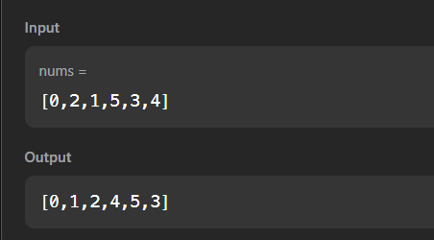

TASK 2.2:SHUFFLE THE ARRAY
PROGRAM:
class Solution {
public int[] shuffle(int[] nums, int n) {
int[] result = new int[2 * n];
for (int i = 0; i < n; i++) {
result[2 * i] = nums[i];
result[2 * i + 1] = nums[i + n];
}
return result;
}
}

OUTPUT:
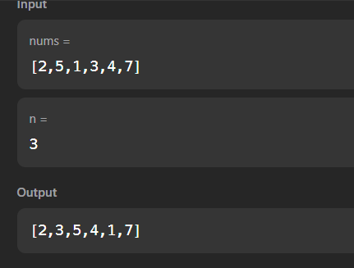

TASK 2.3: FIND THE HIGHEST ALTITUDE
PROGRAM:
class Solution {
public int largestAltitude(int[] gain) {
int maxAltitude = 0;
int currentAltitude = 0;
for (int i = 0; i < gain.length; i++) {
currentAltitude += gain[i];
maxAltitude = Math.max(maxAltitude, currentAltitude);
}
return maxAltitude;
}
}
OUTPUT:
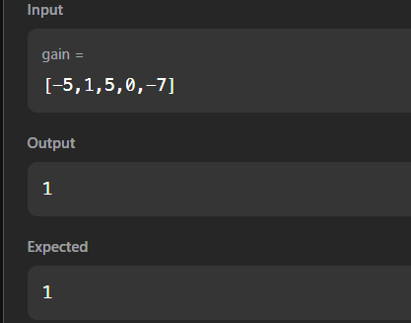

TASK 2.4:JAVA DEQUEUE
PROGRAM:
import java.util.ArrayDeque;
import java.util.Deque;
import java.util.HashMap;
import java.util.Scanner;
public class Solution {
public static void main(String[] args) {
Scanner in = new Scanner(System.in);
if (!in.hasNextInt()) return;
int n = in.nextInt();
int m = in.nextInt();
Deque<Integer> deque = new ArrayDeque<>();
HashMap<Integer, Integer> map = new HashMap<>();
int maxUnique = 0;
for (int i = 0; i < n; i++) {
int num = in.nextInt();
deque.addLast(num);
map.put(num, map.getOrDefault(num, 0) + 1);
if (deque.size() > m) {
int removed = deque.removeFirst();
map.put(removed, map.get(removed) - 1);
if (map.get(removed) == 0) {
map.remove(removed);
}
}
if (deque.size() == m) {
maxUnique = Math.max(maxUnique, map.size());
if (maxUnique == m) {
break;
}
}
}
System.out.println(maxUnique);
in.close();
}
}

OUTPUT:
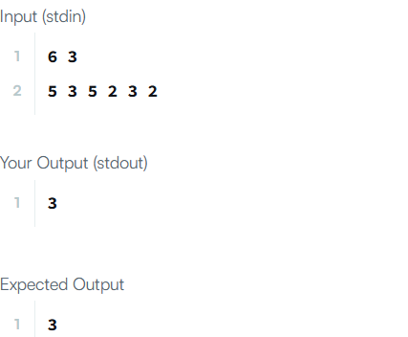

TASK2.5:JAVA HASHSET
PROGRAM:
import java.io.*;
import java.util.*;
import java.text.*;
import java.math.*;
import java.util.regex.*;
public class Solution {
public static void main(String[] args) {
Scanner s = new Scanner(System.in);
int t = s.nextInt();
String [] pair_left = new String[t];
String [] pair_right = new String[t];
for (int i = 0; i < t; i++) {
pair_left[i] = s.next();
pair_right[i] = s.next();
}
HashSet<String> pairs = new HashSet<>(t);
for (int i = 0; i < t; i++) {
pairs.add(pair_left[i] + " " + pair_right[i]);
System.out.println(pairs.size());
}
}
}

OUTPUT:
